**siselRIPT**

Key Terms:

**EAAs (essential amino acids):** siselRIPT contains all of the EAAs that your body needs for optimal muscle anabolism (recovery and building phase). EAAs can only be consumed through your diet for your body to function and feel the best that it can. Below is a graph of the quality of proteins found in foods that people consume fairly regular.

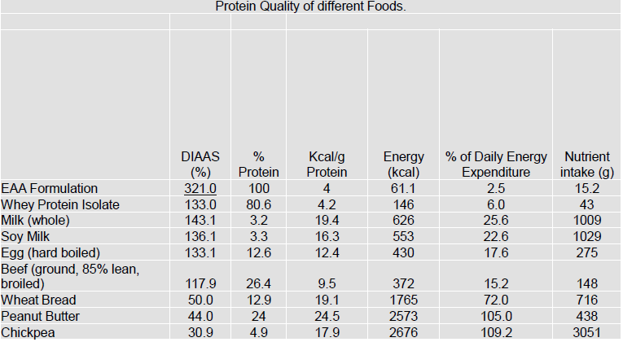

**Anabolic Response:** The chemical reactions that synthesize molecules in metabolism. Note: Athletes often attempt to improve their performance by speeding up this molecule-building process.

**Improve Muscle Fiber:** Muscle fibers are numerous elongated contractile cells that make up striated muscle. Potentially increase muscle size and density. Size and density are two totally different things. Density refers to the muscles firmness (harder not bigger). Size is pretty self-explanatory.

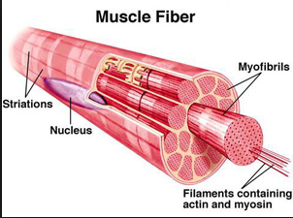

**Muscle Quality:** Is closely intertwined with muscle strength, as muscle quality is typically defined as muscle strength or power per unit of muscle mass.

**Optimal Amino Ratio:** Proteins are made up of different combinations of amino acids and the ratio of those amino acids determines the efficacy that protein has on your muscles. Too much of an amino acid can cause oxidation lessening the effect that the amino acid has on the muscles. Too little of an amino acid causes your body to steal it from other organs and muscles in your body.

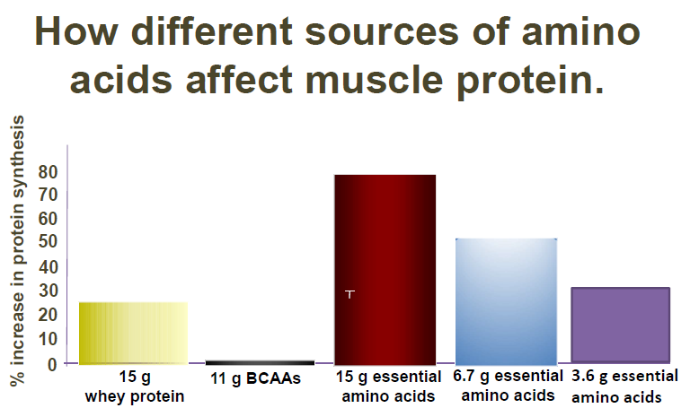

**Muscle protein synthesis (MPS):** The driving force behind adaptive responses to exercise and represents a widely adopted proxy for gauging chronic efficacy of acute interventions, (i.e. exercise/nutrition). (definition from NIH.gov)

More simply put **MPS** is the rebuilding of muscle tissue.

Intended Uses/Other Information

siselRIPT is intent is to be a muscle health supplement and sport supplement. Benefits are found to help those who exercise and want to improve muscle health and quality, the aging population build muscle and for the “weekend warriors” (people that do not exercise often) to build muscles with minimal exercise. Some have said that they have experienced weight loss while taking this supplement.

siselRIPT is truly a miracle product that helps increase muscle strength and shortens recovery time. This is found through our own internal testing here at Sisel International and through 23 clinical studies that were conducted by 2 of the top NIH researchers in the nation at a top University of Medical Science.

siselRIPT was created and designed with long-term muscle health in mind.

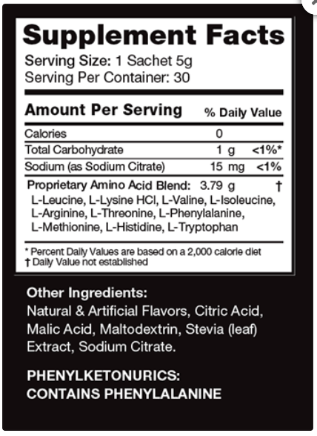siselRIPT can truly help your muscle function making you feel stronger and more fit with minimal exercise.

You ask…why the use of L-Phenylalanine in the new Sisel RIPT product.

There are 3 forms of Phenylalanine. L-phenylalanine is an essential amino acid found in protein, in nature. It’s considered safe and is essential, which means your body needs it and cannot make it. Another form, D-phenylalanine is made in a lab and it is not found in your food. It is also not essential for the human body. The 3rd form of phenylalanine is called DL-phenylalanine and it is the mix of the D and the L forms of phenylalanine. It again only comes from a laboratory.

Sisel RIPT uses the natural, L-Phenylalanine.

There are 20 amino acids that our bodies need. 11 are nonessential, meaning that our body can manufacture them. 9 are essential. That means you have to get them from the diet.

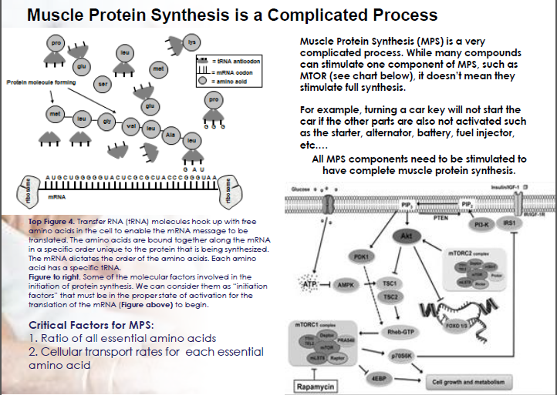

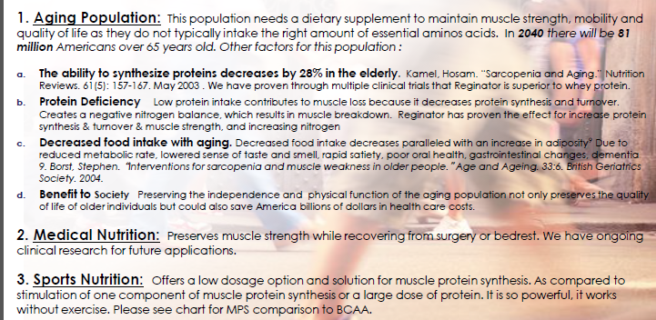

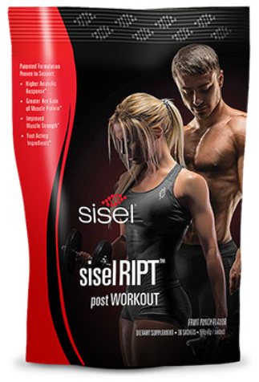

**SiselRipt**

…offers a state-of-the-art way for you to grow, repair and maintain muscle mass. Created with long-term muscle health in mind,

**SiselRipt**

provides the most efficient ratio of Essential Amino Acids needed for Muscle Protein Synthesis.

**Sisel Ript**

With more than $20 million in research and 24 human trials, our unique, patented formula is clinically proven to provide superior muscular growth, regeneration, and conditioning.

**Studies show that Brain health is dependent on Amino Acids** Obsessive-Compulsive Disorder. ... As discussed earlier, the amino acid tryptophan is a precursor to serotonin, and tryptophan supplements (which are better than 5-Hydroxytryptophan) will increase serotonin levels and treat OCD (Pub Med Studies)

**ADHD, Anxiety, Dyslexia** (studies by Dr. Levinson)

**Adrenal Fatigue**: L-Taurine: This is a neuroprotective amino acid that works to help maintain cell stability. It also has anti-oxidant activity and supplementation has been shown to increase the inhibitory neurotransmitter in the brain called GABA. This should help improve sleep, mood, calmness and relaxation. L-Taurine is also found in eye health.

**Parkinson’s**: The Parkinson's disease process is known to be associated with depletion of serotonin, tyrosine hydroxylase, norepinephrine, and dopamine. L-dopa is known to deplete serotonin, serotonin precursors, tyrosine, and the sulfur amino acids. Feb 28, 2011 (Amino acid management of Parkinson's disease: a case study)

**Duchenne Muscular Dystrophy**: Although Duchenne MD is present at birth, signs and symptoms do not ... Amino acids: including glutamine and arginine for muscle protection.

Another study shows: Loss of a single amino acid from dystrophin resulting in Duchenne muscular dystrophy with retention of dystrophin protein. 1.

**Multiple Sclerosis**: Excitatory amino acids and multiple sclerosis: evidence from cerebrospinal fluid.

Study’s done by: Sarchielli P(1), Greco L, Floridi A,: Recent evidence suggests an altered glutamate homeostasis in the brain of patients with multiple sclerosis (MS), as seen in experimental models of MS. (NCBI)

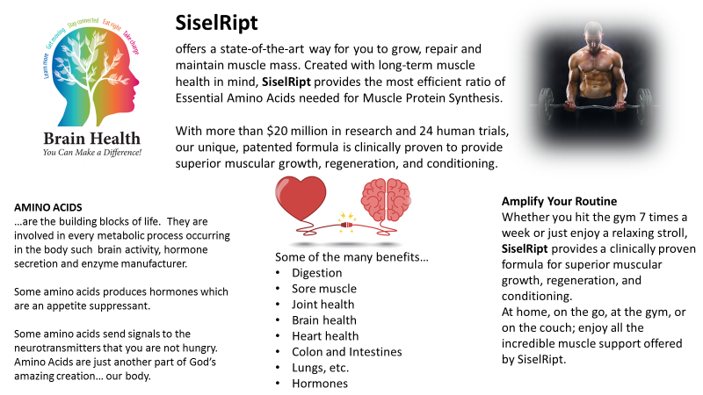

Milo Acosta’s mother had a knee replacement surgery just as this product came out. So right after the surgery, she started drinking the **SISELRIPT.** The Dr. was astonished at how fast her recovery time was. In her 2nd week she was walking with her cane, and recovery from there went very fast.

This product is not just for those who are young and athletic…

It is especially good for the aging as well.